COEN 210 Project #2, Spring 2018

In this project, you are going to model a 4 pipeline stages RISC-V microprocessor in C; or any programming language (C++, Java) or hardware description language (Verilog, VHDL, System C). You are given 2 trace files which have instruction addresses and RISC-V instructions as they are executed by a microprocessor. The microprocessor consists of 4 pipeline stages as in class lecture:

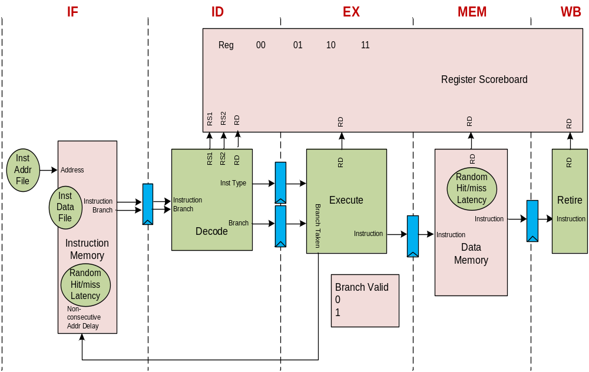

- The first pipeline stage will read, one at a time, the instruction address and instruction from inst_addr_trace_hex_project_2.txt and inst_data_trace_hex_project_2.txt, respectively.
  - Random number of hit/miss: assume the miss rate for instruction cache is 0.8%. (clock_cycle%128)=55 is the cache miss, everything else is cache hit:
    - Hit: the clock cycle is increment by 1
    - Miss: the clock cycle is increment by 15
  - Since all the instructions are 32-bit, check only for non-consecutive address = taken branch, the fetch is stalled until the valid indication from the branch execution unit
    - Note: for consecutive address, use max time of IF and ID, for non-consecutive address, use max time of IF, ID, and branch_state_0
  - The instruction sends to the next pipeline stage includes: time stamp
- The second pipeline stage decodes instruction (RISC-V description is in the last 6 slides of chapter 2 lecture)
  - Instruction can only be accepted if the current clock cycle is greater or equal to the time stamp of the instructions from the first pipeline stage and the last decoded instruction
  - Instruction type decode: branch, ALU, or load/store
  - Note: if the opcode is not in the table of page 18 of Chapter 2 lecture, then assume NOP. The instruction count is +1, going through the pipeline but there is no dependency. Another instruction type is SYSTEM which should also be treated as Branch instruction. The encoding should be:
Instruction inst[6:2]
Load 00_000
Store 01_000
Branch 11_0?? & 11_10?
ALU 0?_10?
- Note:
  - JAL is CALL instruction - call to subroutine and save the sequential address (PC+4) into the link register (Rd)
  - JALR is RETURN instruction - finish the subroutine and return to the main program using the link register (Rs1)
  - Any instruction with Rd will write to register file, in this case, the PC+4 is used to write to the link register. The PC+4 value is known and Rd is treated the same as Rd for ALU instruction. The dependency should be the same normal read/write dependency.
  - R0 is not a real register, the same as MIPS instruction set. If R0 is a source register, then it reads 0. If R0 is a destination register, then the write is ignore.
  - Operand decode: Sources and destination
  - A scoreboard is used to indicate if the register is ready. The destination operand will set the scoreboard bits. The source operand checked the scoreboard to see if the register can be read:
    - 00: register file read
    - 01: forward from EX stage
    - 10: forward from MEM stage
    - 11: stall
  - The instruction is sent to the next stage based on when the source operands are ready
    - Time stamp = clock_cycle + 1, if no stall
    - Time stamp = clock cycle of when source operand are ready
- The third pipeline stage executes instructions: ALU and branch instruction
- The ALU and JAL instruction sets the scoreboard bits for the destination register to 01 which should be seen immediately by the decode stage for forwarding
- The taken branch instruction causes the instruction memory to fetch the next instruction. A valid indication is returned to first pipeline stage to enable fetching of target instruction
- The fourth pipeline stage execute the load/store instructions
  - Random number of hit/miss: assume the miss rate for data cache is 6.25%. (clock_cycle%16)=11 is cache miss, everything else is cache hit.
    - Hit: the clock cycle is increment by 1, the scoreboard bits is set to 10 which should be seen by the decode stage immediately
    - Miss: the clock cycle is increment by 15, the scoreboard bits is set to 10 by the miss time which should be used by the decode stage if there is data dependency
  - For ALU and JAL instruction, the scoreboard bits is set to 10 for destination registers which should be seen immediately by the decode stage
  - If load operation is a cache miss and next instruction is ALU or branch without any data dependency on the load destination register?
- The fifth pipeline stage writes result data to register file
- The ALU, load instruction, and JAL sets the scoreboard bits for the destination register to 00 which should be seen immediately by the decode stage

The model does not actually execute the instructions, only the instruction address, instruction, and register addresses are used in the model. The purposes of the program are:
- Decoding of instructions
- Data dependency and stalling of instructions
- Control dependency and flushing the pipeline on taken branch
- Impact of stalled cycles for instruction cache miss and data cache miss

Two more experiments, random number is input parameter
- Double the miss rate for instruction cache, (clock_cycle%64), same data cache miss rate
- Half the miss rate for data cache, (clock_cycle%32), same instruction cache miss rate as in original case

COEN 210 Project #2, Spring 2018

Collecting statistical data:
- Number of data cache load accesses
- Number of data cache store accesses
- Number of instruction cache accesses
- Number of hits for instruction cache and data cache
- Number of instructions for each type: ALU, branch, load, store, and all
- Number of taken branches
- Number of forwarding from EX stage. ALU instruction
- Number of forwarding from MEM stage. ALU and load instruction
- Stalled cycles in ID stage
- Total cycles

Calculations:
- Hit ratio
- Instruction per cycle (IPC)
- Percentage of taken branches over total branches
- Instruction type frequency for ALU, load, store, branch
- Percentage of stalled cycles over total cycles

Put the statistical data and ratios into a table (15 rows of data):
Experiment number | 1 | 2 | 3
Number of data cache load accesses
Number of data cache store accesses
Number of instruction cache accesses

Discuss the impact of three experiments base on the statistical data and ratios.

COEN 210 Project #2, Spring 2018

Example of instruction modeling and pipelining:

- An ALU instruction would have the following time stamp:
  - IF = N, ICache_hit++, ICache_access++
  - ID = N+1 (no dependency)
  - EX = N+2
  - MEM = N+3
  - Scoreboard, RD – say R5:
    - 11: N+1
    - 01: N+2
    - 10: N+3
    - 00: N+4
- Next ALU instruction:
  - IF = N+1
  - ID = N+2, RS1=R5 and R5=01 at N+2 (equal to current clock cycle), so it is OK to issue, ALU_EX_forwarding++
  - EX = N+3
  - MEM = N+4
  - Scoreboard, RD, say R6:
    - 11: N+2
    - 01: N+3
    - 10: N+4
    - 00: N+5
- Next load instruction:
  - IF = N+2
  - ID = N+3, RS1=R5, it is OK to issue, ALU_MEM_forwarding++
  - EX = N+4
  - MEM = N+5
  - Scoreboard, RD, say R7:
    - 11: N+3
    - 01: 0
    - 10: N+5 or N+19 (if miss); DCcache_hit++ or DCache_miss++
    - 00: N+6 or N+20 (if miss)
- Next ALU instruction:
  - IF = N+3
  - ID = N+4, RS1=R6 and RS2=R7, R6 = 10 (OK) but R7=11, inst_stall = inst_stall + (N+19 – N+4), forward at N+19, LD_MEM_forwarding++
  - EX = N+20
  - MEM = N+21
  - Scoreboard, RD, say R8:
    - 11: N+4
    - 01: N+20
    - 10: N+21
    - 00: N+22
- Next ALU instruction:
  - IF = N+4
  - ID = N+20 → greater time from If (N+4) or previous ID (N+19) - RS1=R8 and R5=07, OK to issue, ALU_EX_forwarding++
  - EX = N+21
  - MEM = N+22
  - Scoreboard, RD, say R6:
    - 11: N+20
    - 01: N+21
    - 10: N+22
    - 00: N+23
- A branch instruction would have the following time stamp:
  - IF = N+5
  - ID = N+21 (no dependency)
  - EX = N+22, branch_valid
  - MEM = N+23
  - Branch_valid_state
    - 1: N+23
    - 0: N+24
- Next non-consecutive PC instruction:
  - IF = N+24 (if non-consecutive then use the time of branch_valid_state +1)
  - ID = N+25 → greater time from IF (N+24) or previous ID (N+21)
  - …

Example used in class:
PC=0x10 sub $2, $1, $3
PC=0x14 lw $12, 24($2)
PC=0x18 or $13, $12, $2
PC=0x1c add $14, $12, $2
PC=0x20 sw $14, 100($2)
PC=0x24 add $3, $1, $4
PC=0x28 beq $5, $6, 7 // $5==$6
PC=0x4c lw $4, 50($7)

